

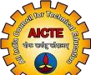
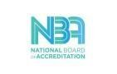
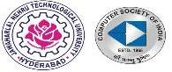

Department of CSE (Computer Science Engineering)

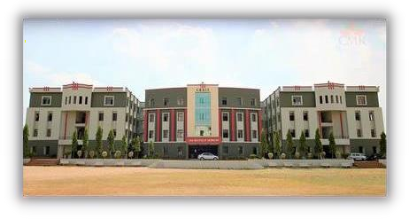

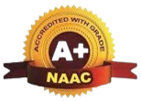

Organizing
A ONE WEEK
FACULTY DEVELOPMENT PROGRAM ON

Fundamentals of


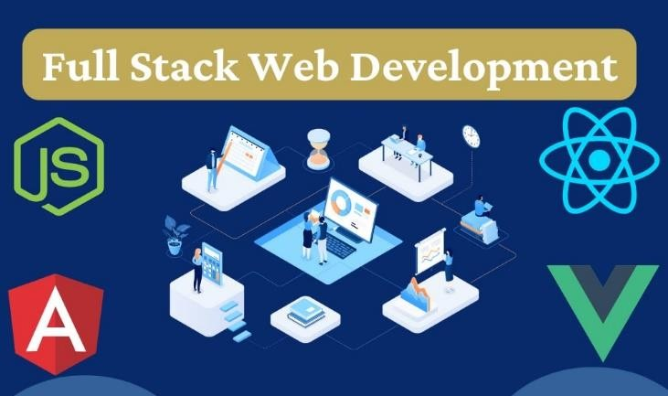
NODE JS/ANGULAR/REACT JS/DJANGO

01-12-2025 to 05-12-2025
Resource Person:

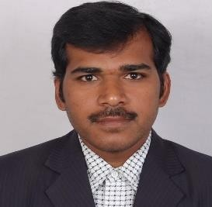
A. Sarveswara Reddy
Assistant Professor-CMRIT ABOUT THE RESOURCE PERSON
A. Sarveswara Reddy, Assistant Professor (CSE), has 7 years of teaching and 13 years of industry experience in MNCs, with strong programming knowledge and excellent communication skills.

ABOUT THE INSTITUTE
Vision:
To create world class technocrats for societal needs.
Mission:
Impart global quality technical education for a better future by providing appropriate learning environment through continuous improvement and customization.
CMR Institute of Technology is one of the best Engineering Colleges for aspiring engineering students. It is one of the three Colleges established by the MGR Educational Society. CMR Institute of Technology was established in 2005 in 10 Acres with single-minded aim to provide a perfect platform to students in The field of Engineering, Technology, and Management for their a cadmic and overall personality development. The College has a rich tradition of soaring high with academic excellence & overall personal growth of students

ABOUT THE DEPARTMENT
Vision:
To create world class technocrats for societal needs.
Mission:
Achieve global quality technical education by assessing learning environment through
- Innovative Research & Development
- Eco-system for better Industry institute interaction
- Capacity building among stakeholders

Topics to be covered:
Web Development for Server-side architecture.
- Node.is (JavaScript Web Framework)
- Django (Python Web Framework)
- MongoDB
Web Development for Client-side architecture.
- Angular JS (Javascript/TypeScript Framework).
- React JS (Javascript Web Framework).
Chief Patrons:
Sri. Ch. Malla Reddy Founder Chairman, CMRGI. Ch. Narashima Reddy
Vice-Chairman, CMRGI. P a t r o n s :
Sri. Ch. Gopal Reddy
Secretary correspondent, CMRGI
Ch. Abhinav Reddy CEO, CMRGI
Co-Patron:
Dr. M. Janga Reddy Director, CMRIT Convenor:
Dr.B. Satyanarayana Principal, CMRIT Coordinators:
Dr. K. Pradeep Reddy
Head-CSE, CMRIT.
Prof.A. Prakash
Professor, CSE, CMRIT.
Organizing committee:
Dr. S. Alagumuthu Krishnan
Associate Professor, CSE, CMRIT.
Dr. Vinit Kumar Gunjan
Associate Professor, CSE, CMRIT.

REGISTRATIOM FORM
Name: Designation: Qualification & Experience: Institution: Mobile No. : Email id:

Date: Signature of the Applicant

